FUNCTIONS GRADE 10
Function
A function is a mathematical relationship between two variables, where every input variable has one output variable.

Representations of functions
Functions can be expressed in many different ways for different purposes.

Words: “The relationship between two variables is such that one is always 55 less than the other.”

Mapping diagram:
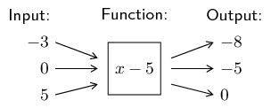
- Table

Input$(x)$ | -3 | 0 | 5
Output$(y)$ | -8 | -5 | 0

Set of ordered number pairs: (−3; −8), (0; −5), (5; 0)

Algebraic formula: $y=f\left(x\right)=x-5$

Graph:
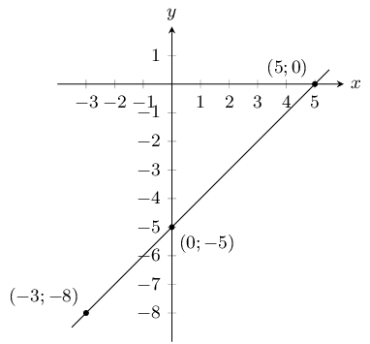

EXERCISE 1
- Given that $y=x+3$ , complete the input and output diagram below:
Input: Function: Output:
-1
$$x+3$$
0
1

- Given that $y=\frac{1}{2}x-2$

Input $(x)$ | -2 | 0 | 2
Output$(y)$

